Syncom has the solution for the aged portfolios you have decided not to sell.
For 20+ years, Synergetic Communication has successfully collected later staged debt in the ARM Industry. For the past seven years, we have helped many existing customers to increase recoveries on accounts that have gone past their typical assignment tiers. This program becomes more valuable as compliance requirements have complicated the ability to sell aged debt confidently. The La$er program is a great alternative to selling. Syncom is a secure and compliant agency that has a proven track record of success on accounts 2-6 years from charge off.
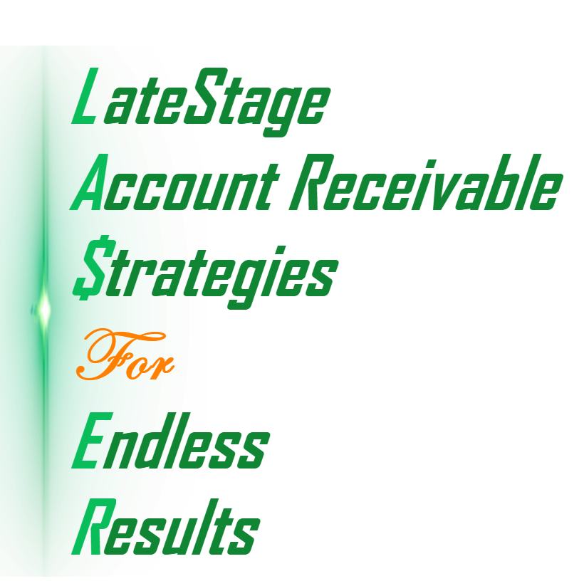
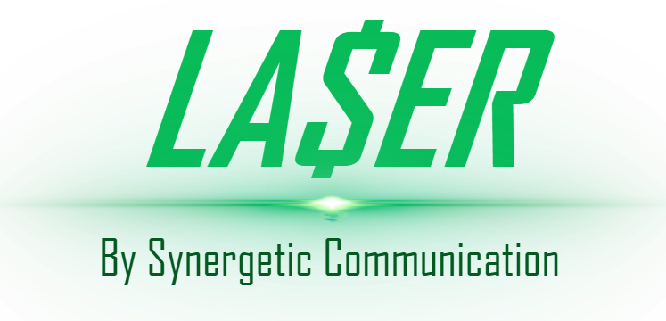
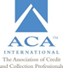

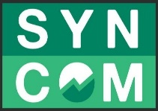

LA$ER is a proven late stage program that will dynamically pinpoint accounts that have a propensity to pay based on their most current positive credit activity. Syncom will monitor each account daily for positive improvement for the each consumer in your portfolio. The activity on the account will be laser focused and customized for the individual consumer. A certain percentage (typically 3%) of the portfolio will have the expected positive activity occur on a monthly basis. This will create an endless stream of opportunities to collect on accounts when they have the highest propensity to pay, thus creating a consistent recovery stream that will produce for as long as the accounts are placed with Syncom. The typical portfolio is aged 2-6 years from charge off.

Most warehouse programs are passive and wait for the consumer to initiate activity. LA$ER will work the accounts upon placement to jump start the program. We score all accounts and scrub them to determine their current propensity to pay. We will letter and work every account, and at the same time flagging each account for improvement into their credit history. These accounts are then routed to an active collection process based on the dynamic of that account. The amount of initial work will be determined by our segmentation of the accounts.
The determined path is then executed to maximize the potential to collect. We will utilize dialing, skip trace and letter strategies that can take from 90- to 120 days. If the collection efforts don’t finalize the account, we will replace the flags at day 120 and wait for another positive reason to initiate activity. This process is endless as long as we have the account placed with us. As a consumer improves their situation the opportunity to collect can improve over time. Continuing to rework the account helps to create the endless and consistent liquidation of a portfolio you won’t see in traditional late stage work efforts. Their efforts are front loaded and typically wane to nothing after 120 days. They will only work the accounts they have in a payer status.
LA$ER recoveries will be consistent month in and month out adjusting during seasonality typical of our business. As of January 2019, we are monitoring over $4.2 Billion in the LA$ER program.

